2.0 Engineering Problem
Modern Buildings rely on a heating, ventilation and air-conditioning (HVAC) system to maintain a comfortable indoor condition for the occupants. However, throughout the day the amount of people in the building can vary significantly affecting the demand of the system to control the conditions of the room. Normally HVAC systems are on fix schedule which may not accurately represent the occupancy of the room or may take longer to change to the rooms new occupancy which can waste energy and is inefficient. Therefore, the use of a numerical system can be incorporated to make the system more responsive by predicting the current occupancy. The current data being provided gives the occupancy of 5 rooms inside the building. However, the models will only be trained and validated for one of the rooms and it is assumed that it can be re-trained against the data in the other rooms and be just as successful. The aim of this project is developing a decision tree regression model capable of predicting room occupancy 15 minutes in advance using historical occupancy measurements and time-based variables. The model will be evaluated against Historical Average, Linear Regression and Support Vector Regression methods to determine its accuracy and suitability for occupancy prediction. The model will only look at one room for predicting, with limitations of missing measurements, sensor data and the model’s ability to predict unexpected changes in the occupancy.

3.0 Input and Output Data

3.1 Input Data
 | Meaning | Unit | Allowed Variable
Floor space id | Which Room | Text | Any room number
HeadCount | The total occupancy | integer | Zero or more
CollectedDate | Time of Data | Date and time | Any Date and time

The method uses three variables with the floor space id being filtered out early so that only the selected room can be used to train the model. The Head count is also turned into what is the room occupancy and then the CollectedDate is split into date, hour and minute.

3.2 Output Data
 | Meaning | Unit | Intended Use
Input Time | Current Time | Any 15-minute interval time | See the occupancy at that time
Current Occupancy | Current Occupancy at that time | Positive integer | Allows for the model to be compared
Predicted Occupancy | Model’s predicted occupancy | Positive integer | Value given to the HVAC system

The main output is the predicted occupancy where it is given in intervals of 15-minutes after the input observation. The Current occupancy is used to evaluate how well the model was able to predict what the actual occupancy will be.

3.3 Data Processing and Limitations
Before the model was made the data was sorted. Firstly, the timestamps were split up and sorted into 15 minute-intervals to be used. Any invalid observations or duplicate timestamps were filtered out this could mean rows with missing head counts. In the situation occurred were there was no new update to the occupancy the previous value is retained up intel 30 minutes where it is then assumed that the room is unoccupied. This assumption enables a continuous time series but may not accurately represent actual occupancy during sensor interruptions.
The initial data also had sensor data where they were multiple different types of sensors inside the room. During the analysis of the data to see what to use these sensors and found that they were incomplete and thus were not used in the model.

4.0 Computational solution

After the data was sorted and organised into its 15-minute intervals it was split up were 70% was training data 15% was validation and 15% was testing data this allows the model not just to learn the data but also be test against unseen data. The method decided was a Decision Tree Regression, a supervised machine-learning technique that is used to predict continuous numerical outputs. The method works by repeatedly dividing the training data into smaller sub-groups using threshold-based decision rules created from the input variables. Each division goal is to reduce the overall variation from the target value; this will then make the final prediction calculated as the mean occupancy of the observation within a terminal node. Do the occupancy of the room showing non-linear relationships to time and previous occupancy and how the change in occupancy takes steps like a decision tree. This method therefore fits the best as it is cable of representing different operating conditions.
The model was done through python the Scikit-learn DecisionTreeRegressor function. The Head count measurements were processed and ran through panda and organised into 15-minute intervals. Six features were created from the core two inputs off occupancy/headcount and time, they were current occupancy, occupancy 15- and 30-minutes prior, minute, hour and day. After this the data was split up were 70% was training data 15% was validation and 15% was testing data this allows the model not just to learn the data but also be test against unseen data. The training data was used to develop the decision rules. The validation set was then used to look at the variables of the Decision tree with them being the tree- depth and leaf-size which was tested to produce the lowest error. The depth-tree is how many question the function will ask to sort the data. The leaf-size is the minimum number of data-points in each final group. If the tree has to many leaves or is to deep it can result in the function over fitting the data. This is why creating an accurate simple model is the best as it will have a reasonable error while not overfitting.
This approach assumes that the historical occupancy and time-based patterns will be enough to create a model that can successfully predict the occupancy 15 minutes into the future. An additional pre-processing assumption is that if the last time will be retained for 30 minutes however once that 30 minutes is up it is assumed that the new occupancy is 0. This may introduce uncertainty when measurements are missing. Finally, the decision can overfit and struggle to predict unexpected changes in room usage. These issues show the importance of validation and variable optimisation when assessing the suitability of the model for making occupancy predictions.

5.0 Alternative Solutions
Three alternative solutions were investigated to confirm that a Decision regression tree would be the best to predict the room occupancy in 15-minutes. The three methods consisted of the Historical Average, Linear regression and Support Regression Vector (SVR). These methods were selected to compare the model on its predicted accuracy, computational complexity, sustainability for modelling occupancy patterns and implementation complexity.

The historical average was implanted as a baseline comparison for the model as it works by using the mead recorded data for that 15 minute time interval for that day of the week. This method is extremely simple as such the computational complexity is extremely simple however as it runs of an average it means that it is unable to respond unexpected in the room occupancy making the method less accurate at modelling change. Additionally, since only the average is being calculated the memory usage is low and the scalability is extremely easy.
Linear regression was selected as the second alternative mathematical solution, using the six numerical input features to estimate future occupancy. This method is quite computationally efficient and has a low memory usage it struggles to model complex non-linear relationships due to is assuming that the data can be represented by a additive linear relationship reducing the overall accuracy for non-linear relationships. This is important as it helps determine if the Decision Tree was needed to model the non-linear relationship
The third and final alternative solution was the support vector regression (SVR). An RBF kernel was used to model relationships between occupancy and time, with the input variables standardised prior to training. Unlike a Decision Tree which works through doing step like predictions SVR can approximate smooth non-linear relationships. However, SVR require more computational resources and is generally less straightforward to interpret. Additionally, due to it have three parameters its scalability is a little harder as it requires these to be re-tested and adjusted accordingly.
These alternative solutions are important as they evaluate the if the additional flexibility and complexity of the Decision tree was needed. These models are compared on their ability using predictive accuracy and computational performance, while looking at there ability to represent changing occupancy conditions. The quantitative results of these comparisons are presented in Section 6.0, while the optimisation and performance characteristics of the primary Decision Tree model are examined in Section 7.0.

6.0
The performance of the Decision Tree Regression model was evaluated by comparing its predicted occupancy values against recorded occupancy measurements from a unseen testing dataset.

Models | Test MAE | Test RMSE | $$R^{2}$$
Decision Tree Regression | 0.576 | 0.898 | 0.278
Historical Average | 0.641 | 0.958 | 0.178
Linear Regression | 0.580 | 0.913 | 0.254
Support Vector Regression | 0.556 | 0.925 | 0.234

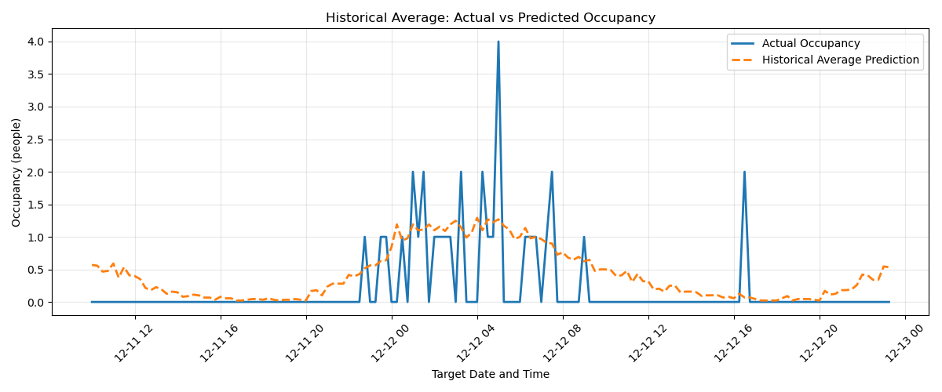 | 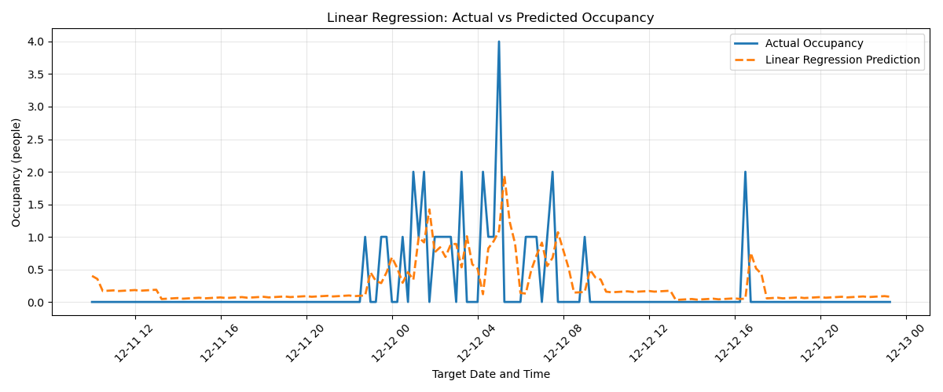
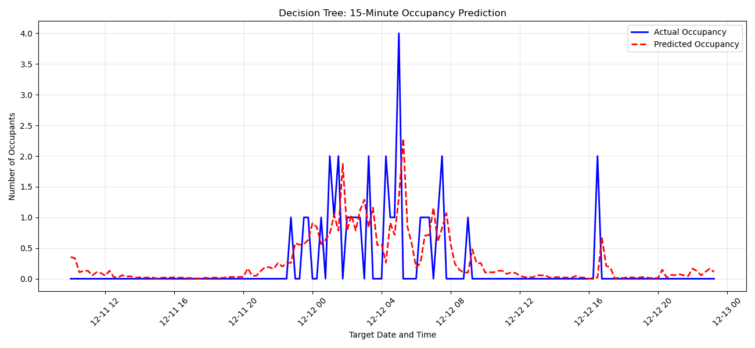 | 